**SmartAttendance**

**Attendance Management System**

**Cloud Computing - ITCS448 - Course Project**

**TABLE OF CONTENTS**

INTRODUCTION 3

SYSTEM ARCHITECTURE 3

Design Considerations 3

The Architectural Design 4

Outlining The Architectural Design 4

IMPLEMENTATION 9

Implementation Details 9

The Challenges We Faced 18

COST ESTIMATION 19

CONCLUSION 20

# **INTRODUCTION**

In this project, we will design and document architecture for “SmartAttedndece” a company that offers smart solutions to schools, universities, and educational institutions. The goal is to build a highly available, reliable, and scalable, robust, and efficient attendance management system that leverages AWS services to handle image processing, face recognition, and data storage. The system utilizes cameras placed in classrooms to capture images every 5 minutes, which are then processed for face recognition in the cloud. The attendance data is stored in a database and made accessible to instructors and students through a web page.

# **SYSTEM ARCHITECTURE**

## **Design Considerations**

1. Build a highly **available**, **reliable**, and **scalable**, **robust**, and **efficient** attendance management system that leverages AWS services to handle image processing, face recognition, and data storage.
2. The system utilizes cameras placed in classrooms to capture images **every 5 minutes**, which are then **processed** for **face recognition** in the cloud.
3. Design a **comprehensive architecture** that encompasses all essential components, including **cameras**, **image processing**, **face recognition**, **database**, **web interface**, and **necessary AWS services**.
4. Data Storage and Management: Design a **scalable** and **reliable** **database solution** using services like Amazon DynamoDB or Amazon RDS to store attendance records securely.

## **The Architectural Design**

*Figure 1: Infrastructure design*

## **Outlining The Architectural Design**

1. **AWS Cloud**: Utilizing the AWS Cloud provides us with the scalability and reliability required to handle attendance management data effectively, ensuring that our system can accommodate increased usage and maintain high availability.
2. **Region**: By selecting a specific AWS region, we can host our Attendance Management System closer to our target audience, minimizing latency and providing a better user experience by reducing the distance between users and our system.
3. **VPC (Virtual Private Cloud):** The VPC allows us to create a private network environment, ensuring the security and isolation of our Attendance Management System. It provides control over network settings, IP addressing, and routing, enhancing the overall security of our system.
4. **Availability Zones (AZs)**: Deploying our system across multiple availability zones ensures fault tolerance and high availability. If one availability zone experiences a failure, the system can continue operating from the other zones, minimizing downtime.
5. **Subnets**: Using public and private subnets allows us to separate different components of our system based on their exposure to the internet. This segregation enhances security by limiting access to sensitive resources and reduces the attack surface of our system.
6. **Internet Gateway**: The Internet Gateway enables users to access the public-facing components of our system, allowing them to interact with the Attendance Management System securely and conveniently.
7. **NAT Gateway**: By leveraging a NAT Gateway, we can provide instances in the private subnet with secure access to the internet. It allows for outbound internet connectivity while blocking inbound connections, ensuring that our system remains protected from unauthorized access.
8. **Load Balancer**: Implementing a load balancer ensures even distribution of traffic across multiple instances, optimizing system performance and providing fault tolerance. It enables us to handle increased user loads and ensures that our system remains responsive and available.
9. **Instances and Databases**: Separating the application logic into instances and storing attendance-related data in databases allows for efficient scaling and management of resources. It enables us to allocate compute resources as needed and ensures that attendance data is stored and managed in a reliable and structured manner.
10. **Security Groups**: Configuring security groups for instances and databases allows us to control inbound and outbound traffic, limiting access to only necessary ports and sources. This enhances the security of our system by preventing unauthorized access and reducing the risk of potential security breaches.
11. **Amazon Route 53**: Amazon Route 53 provides reliable and scalable DNS routing, ensuring that users can access our Attendance Management System using a user-friendly domain name. It improves accessibility and helps users easily reach our system.
12. **Amazon CloudFront**: By integrating Amazon CloudFront, we can cache and deliver static and dynamic content closer to users, reducing latency and improving system performance. It enhances the user experience by delivering content quickly and efficiently.
13. **AWS WAF**: Utilizing AWS WAF adds an extra layer of security to our system by protecting it from common web exploits and security threats. It monitors and filters HTTP/HTTPS traffic, ensuring the integrity and availability of our attendance management data.
14. **Amazon EFS**: Amazon EFS offers scalable and shared file storage, enabling multiple instances to access attendance-related files efficiently and securely. It ensures that our system can handle file storage requirements effectively and supports collaboration between instances.
15. **AWS Recognition**: Leveraging AWS Recognition's facial recognition capabilities enhances security and streamlines attendance tracking through facial authentication. It provides a convenient and secure method for verifying attendees' identities.
16. **AWS Lambda**: AWS Lambda allows us to run custom code without managing servers, enabling automation of tasks, background processing, and execution of custom logic within our Attendance Management System. It simplifies development and maintenance by eliminating the need to manage server infrastructure.
17. **Amazon S3**: Amazon S3 provides scalable object storage for our system, allowing us to store files, images, and other static assets related to attendance management efficiently and reliably. It ensures that our system can handle file storage requirements effectively and provides durability for our assets.
18. **Auto Scaling Group**: Implementing an Auto Scaling Group allows us to automatically adjust the number of instances based on the demand for our Attendance Management System. It ensures that we have the appropriate resources available to handle fluctuations in attendance and user traffic. With Auto Scaling, we can scale up during peak times to maintain performance and scale down during periods of low demand to optimize cost-efficiency. This dynamic scaling capability helps us achieve optimal resource utilization and ensures a consistent user experience, even during high-traffic periods.
19. **Amazon DynamoDB**: Amazon DynamoDB's scalability and fast performance provide reliable storage and retrieval of attendance-related data. It ensures that our system can handle large volumes of data efficiently, delivering fast response times to users. By incorporating Amazon DynamoDB into our Attendance Management System, we can benefit in several ways:

* **High Availability**: Amazon DynamoDB's built-in replication across multiple availability zones ensures that our attendance-related data remains accessible even if one zone experiences a failure. This means that our system can continue to operate seamlessly, providing uninterrupted service to our users.
* **Scalability**: DynamoDB's ability to scale effortlessly is a significant advantage for our system. As our attendance management data grows and user traffic increases, DynamoDB can automatically adjust its capacity to handle the additional load. This ensures that our system can accommodate high volumes of data and user requests without any manual intervention or performance degradation.
* **Reliability**: With DynamoDB, we can rely on its robust data replication and continuous backups to keep our attendance-related data protected. In the event of any unforeseen data loss, we can easily recover from backups. Additionally, DynamoDB offers the option of multi-region replication, allowing us to maintain a replicated copy of our data in a separate AWS region for added resilience and disaster recovery.
* **Performance**: DynamoDB is designed for fast and predictable performance. It optimizes read and write operations to deliver low latency and high throughput, ensuring that our users experience fast response times when interacting with our Attendance Management System. Regardless of the data size or traffic volume, DynamoDB can handle the demands efficiently.

By leveraging the capabilities of Amazon DynamoDB, we can achieve **high availability, seamless scalability, reliable** data storage and **retrieval**, and **excellent performance** in our Attendance Management System. It empowers us to handle large amounts of attendance data **effectively** while ensuring **fast** and **reliable** access for our users.

By leveraging these AWS services, we can benefit from enhanced **scalability, security, reliability, performance optimization,** and **simplified management**, ensuring that our Attendance Management System operates **efficiently** and meets the needs of our users.

# **IMPLEMENTATION**

The implementation of the Attendance Management System involved a series of steps to ensure the successful deployment and integration of the various components. This section provides a brief overview of the implementation process and key considerations considered.

## **Implementation Details**

* **VPC (Virtual Private Cloud):**

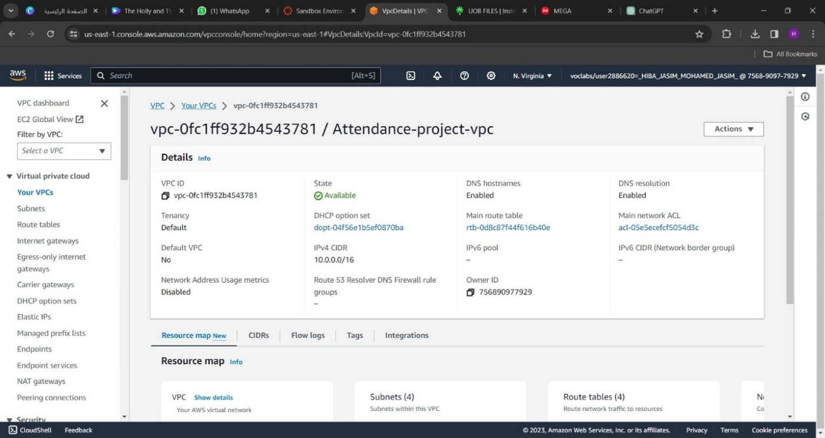

*Figure 2: Attendance-project-VPC*

To deploy the Attendance Management System, the first step is to build the cloud infrastructure, which can be accomplished by establishing a Virtual Private Cloud (VPC) using Amazon AWS. This VPC serves as the initial connection point between our on-premises and cloud architecture. Over the course of several months or years, the infrastructure can be upgraded and enhanced.

* **NAT Gateway:**

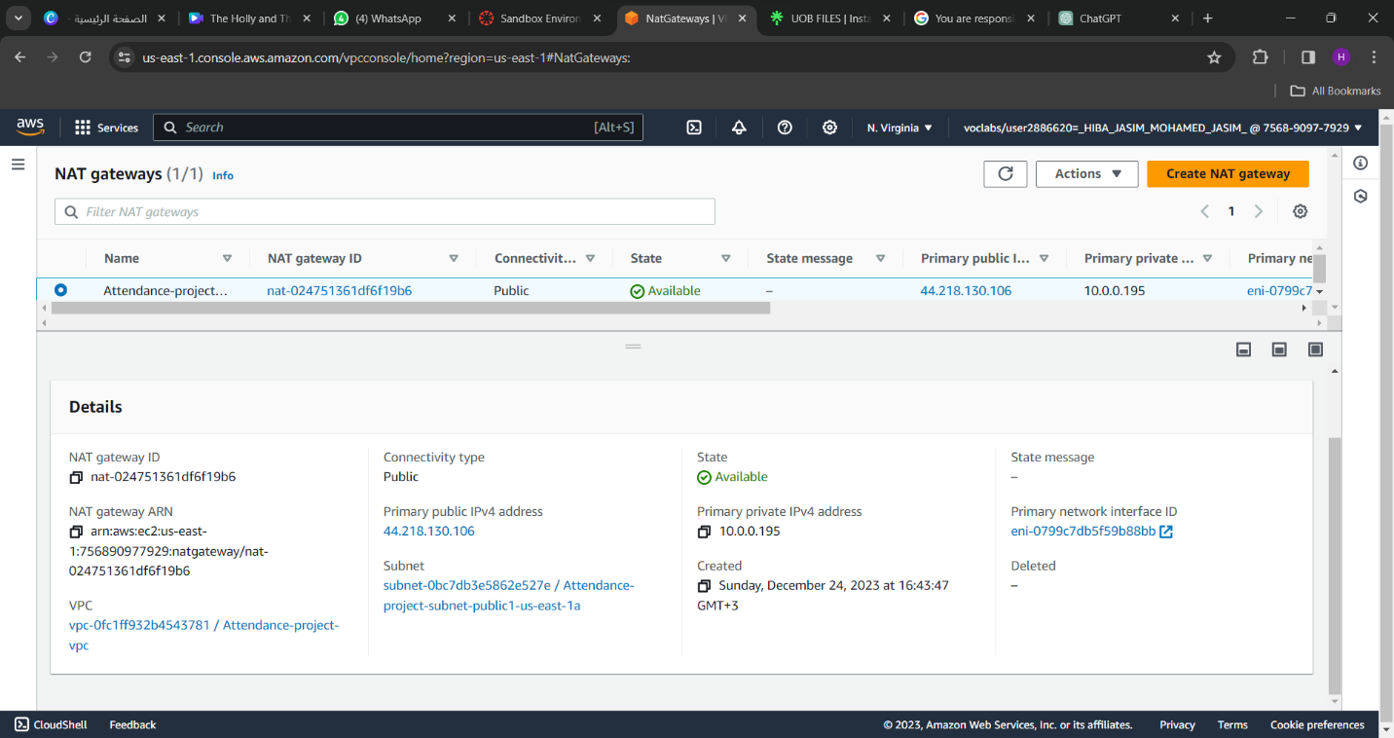

*Figure 3: Attendance-project-NAT getaways*

In the figure 3 we create public NAT getaway is necessary for specific requirements:

* Outbound Internet reach: In order to obtain external resources like patches, software updates, or external APIs, the Attendance Management System may need to reach the outside world. Instances inside private subnets can safely connect to the internet and use these external resources by using a public NAT gateway.
* Third-Party Integrations: It could be necessary to integrate the system with databases or other services that are not housed inside the VPC. The Attendance Management System can link outside to these other resources with the help of a public NAT Gateway, which makes integration and data exchange easier.
* Software Updates and Licensing: Periodic updates or license validation may be necessary for some software components in the system. The system can connect to the necessary servers or licensing services to carry out these actions with the help of a public NAT gateway.
* Remote Administration: The Attendance Management System may require remote management and troubleshooting by system administrators. They can create safe remote connections to the system instances for administrative purposes using a public NAT gateway.
* Monitoring and Logging: An outgoing channel for providing logs and metrics to outside monitoring or logging services is made available by Public NAT Gateways. This makes it possible to monitor, analyze, and troubleshoot system components centrally.

The Attendance Management System can be made more functional, secure, and manageable within the AWS environment by using a public NAT Gateway to securely access the internet, interface with external services, carry out essential updates, and enable remote administration.

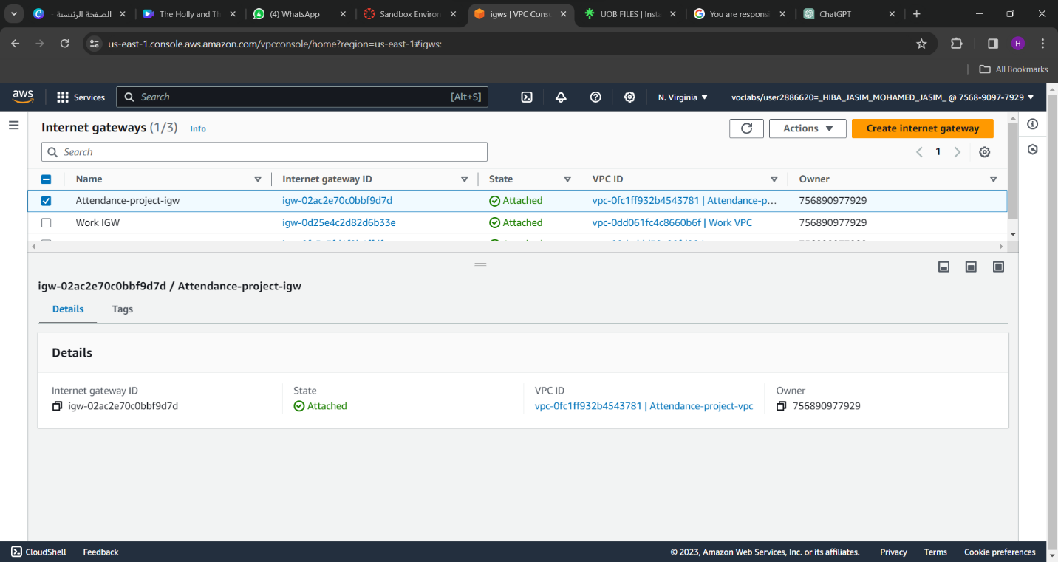

*Figure 4: Attendance-project-igw internet getaways*

Next, we'll install the internet gateway, which will allow public subnets with public IPv4 addresses to connect to the internet.

* **VPC-subnets**

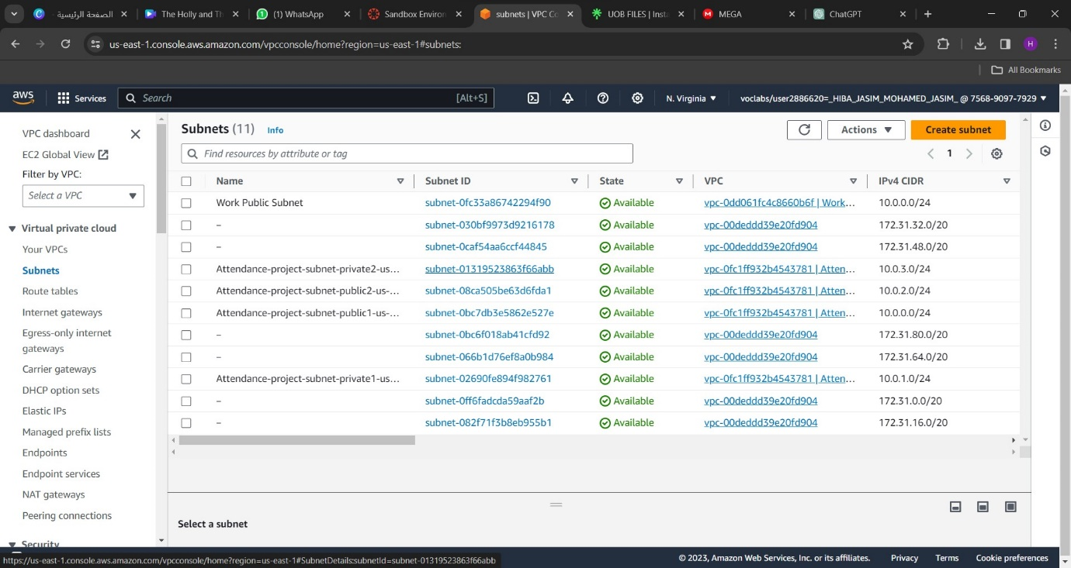



*Figure 5: VPC-subnets*

We will have two availability zones (Availability Zone 1, Availability Zone 2) since operating workloads in two of them will provide higher levels of fault tolerance, scalability, and availability than could be achieved in a single data center. Let’s talk about the subnets now. There will be one subnet for each availability zone, with one public and one private subnet.

Once a subnet has been created, a routing table will be needed for the subnet to begin establishing rules, or routes, that will dictate the direction and destination of network traffic from our subnets and internet gateway.

* **Route tables:**

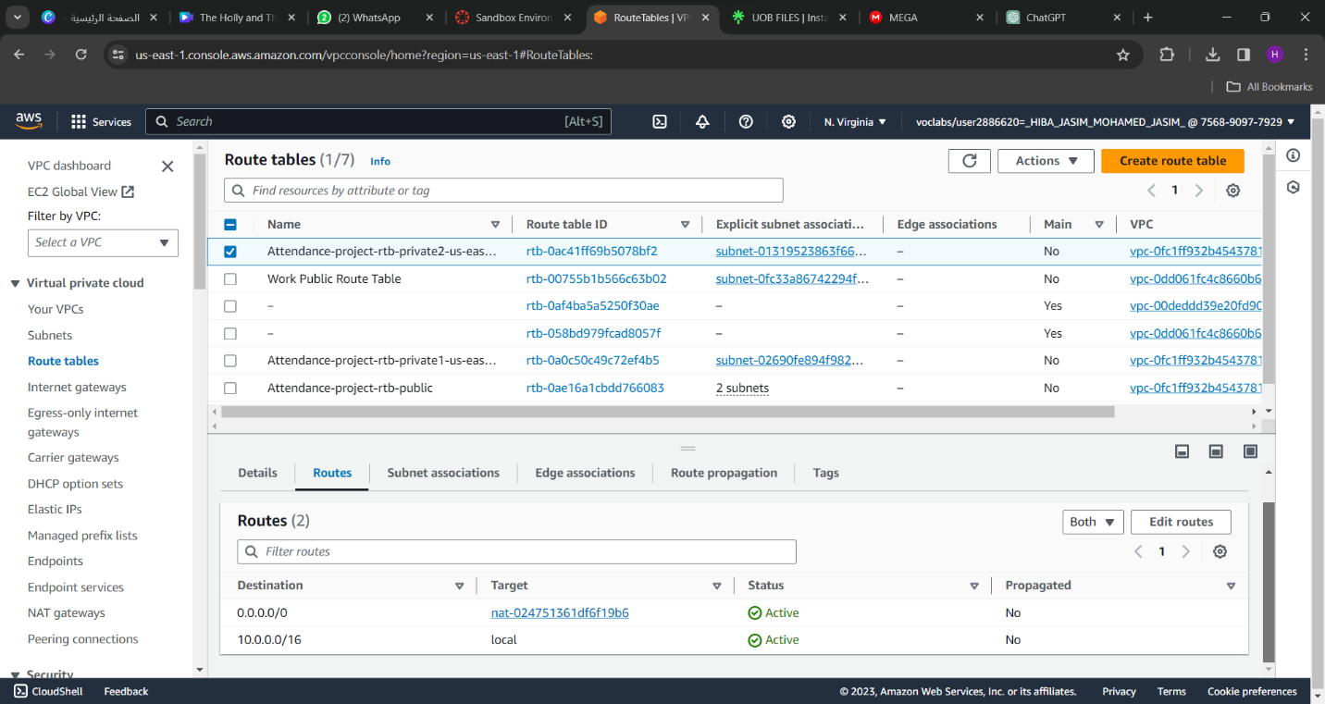

*Figure 6: Route table- Attendance-project(private2)*

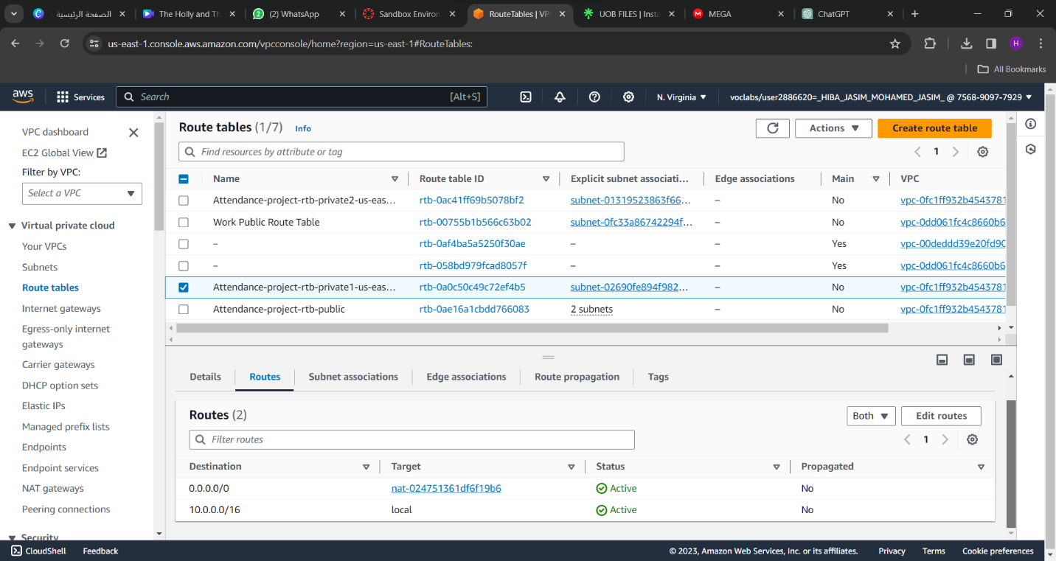

*Figure 7: Route table- Attendance-project(private1)*

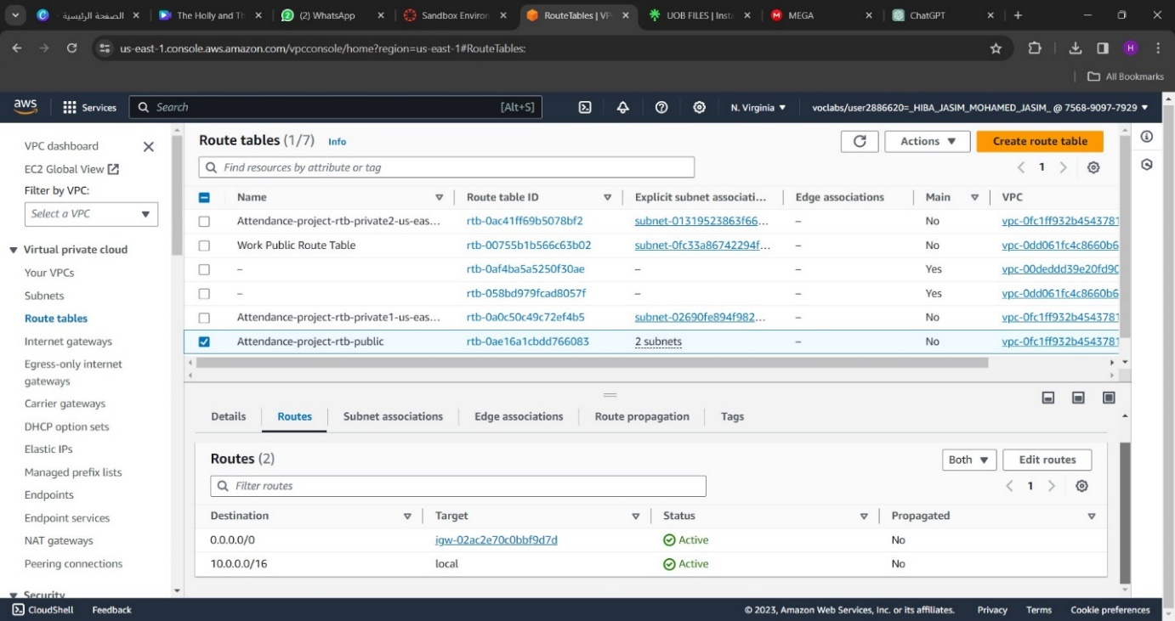

*Figure 8: Route table- Attendance-project(public)*

* **Security Groups:**

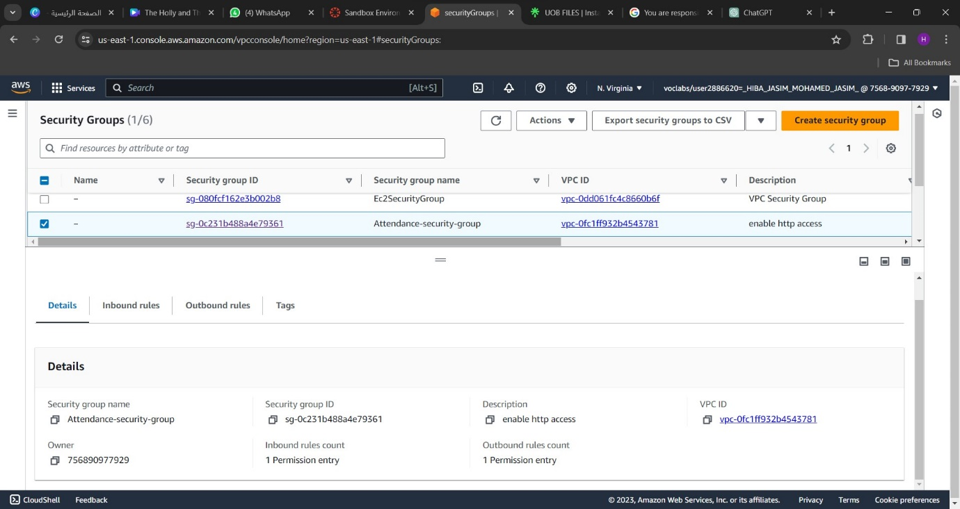

*Figure 9: Security Groups- Attendance-security-group*

An Attendance Management System tracks and manages organizational attendance. Two servers in a private subnet enhance security and privacy by isolating it from the public internet, ensuring data is only accessible to authorized individuals within the private network.

* **Instances:**

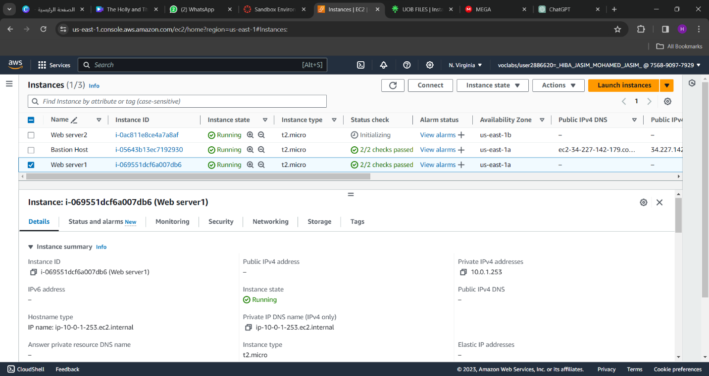

*Figure 10: web server1-details*

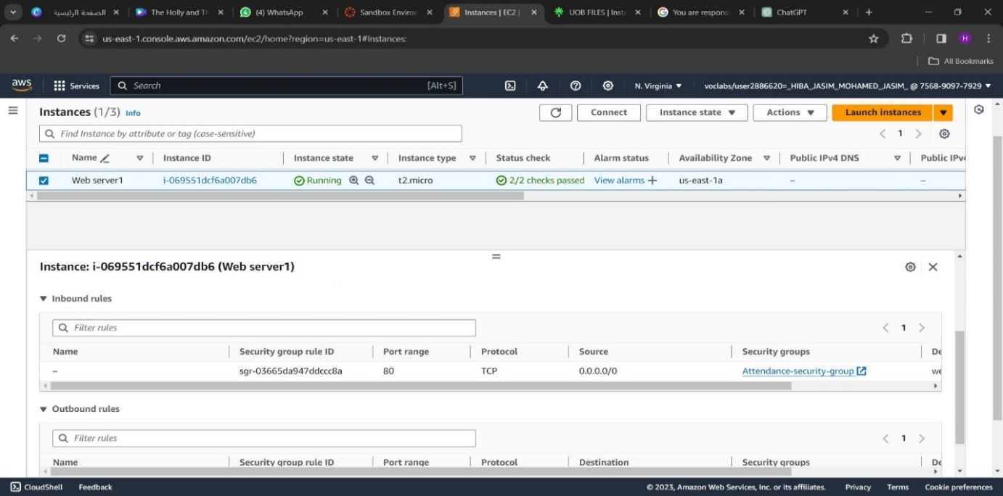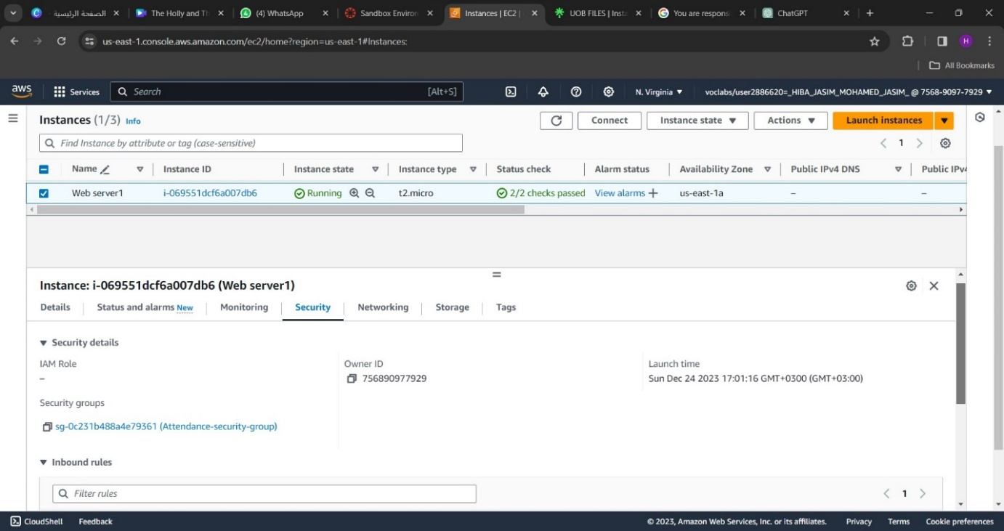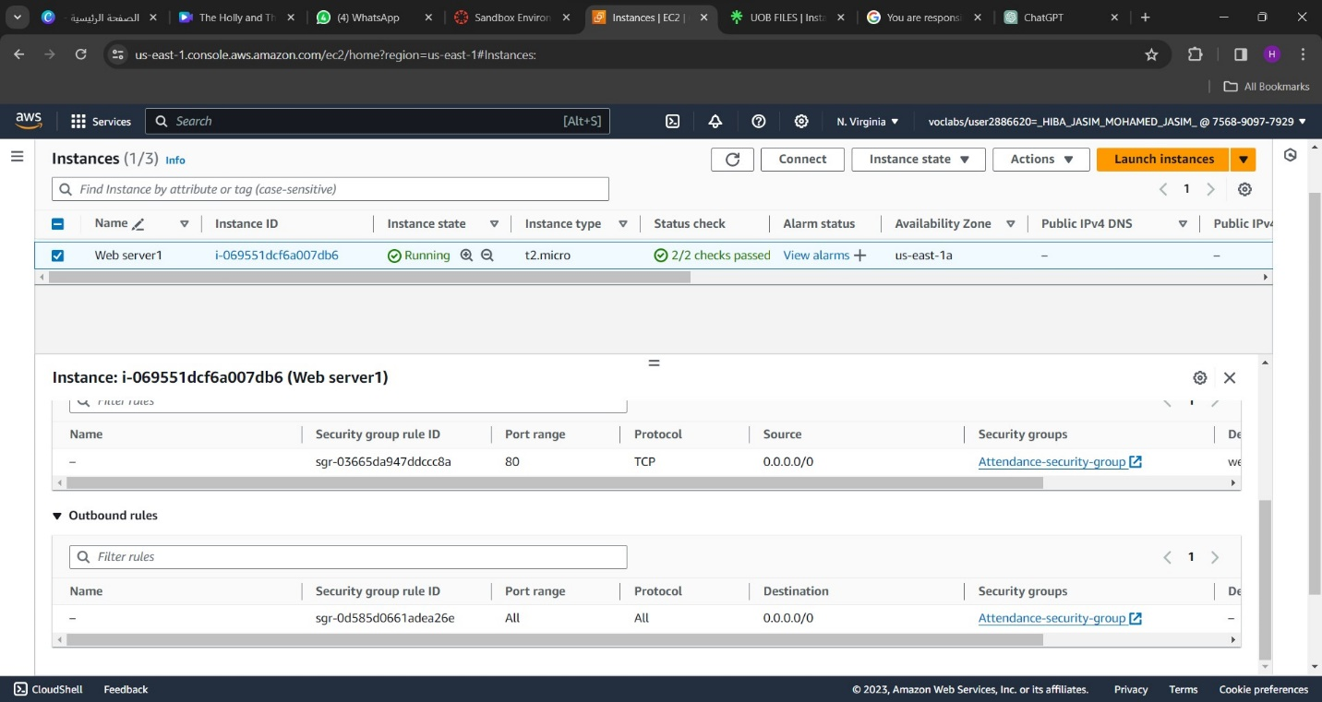

*Figure 11: web server1-security*

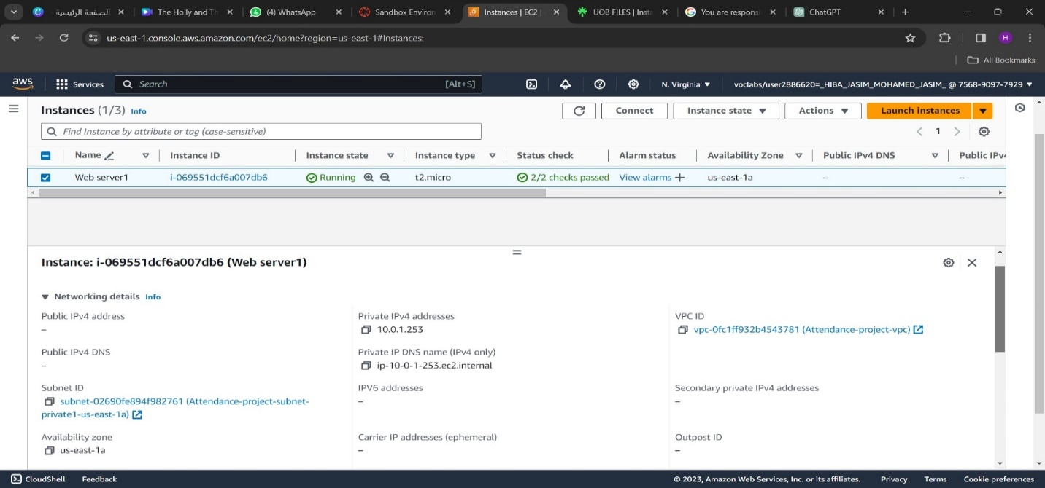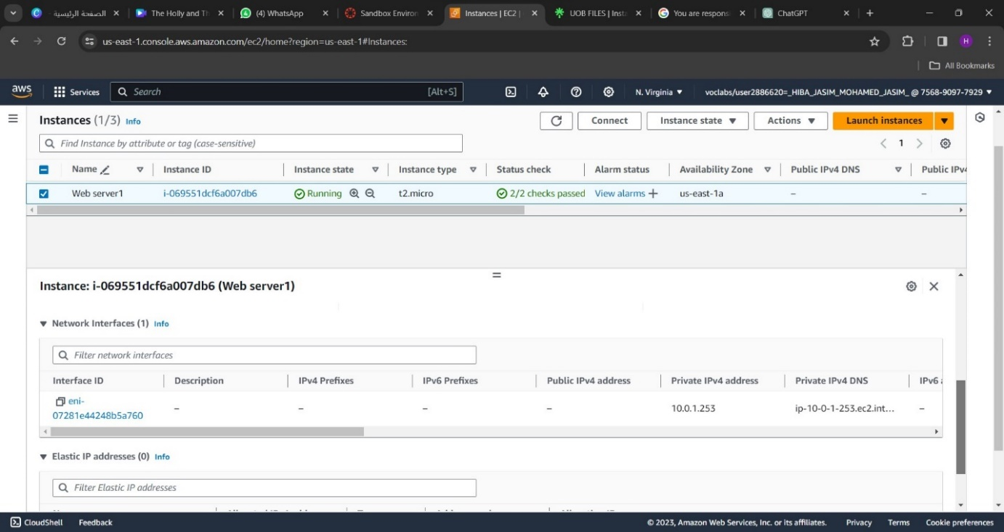

*Figure 12: web server1-networking*

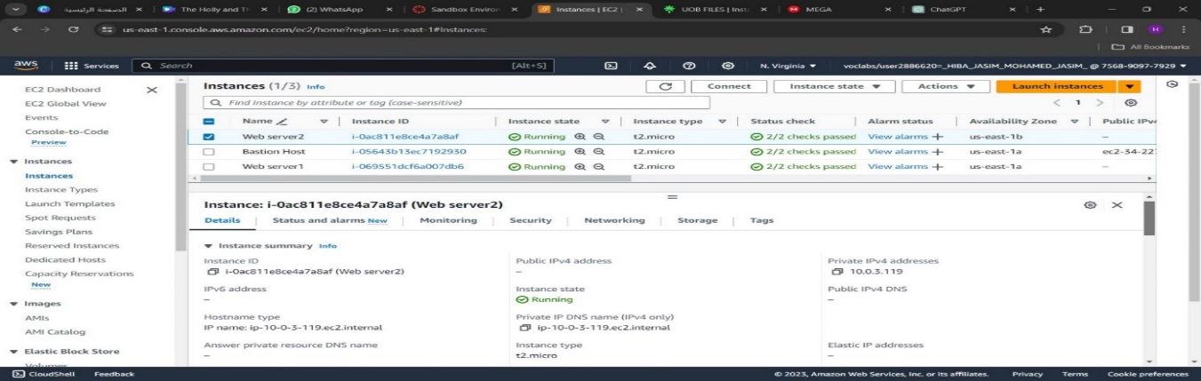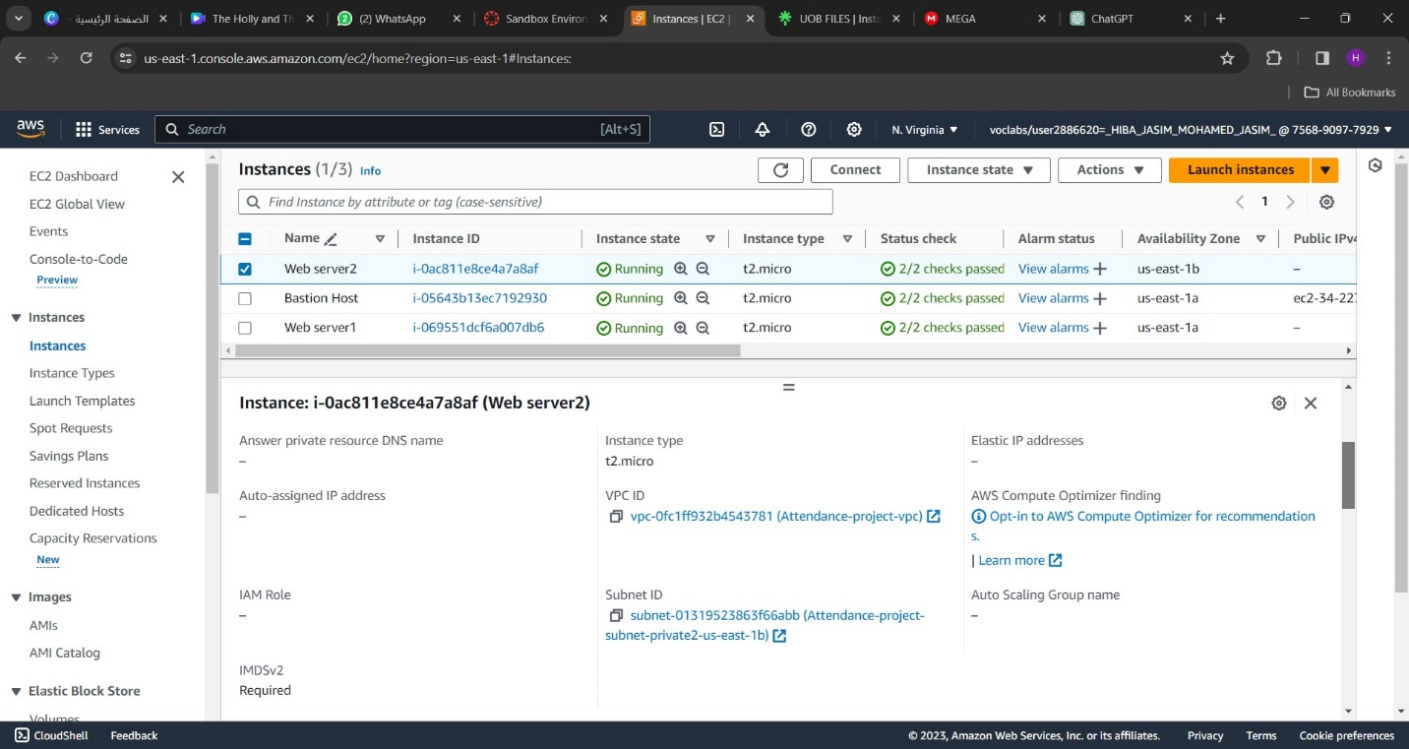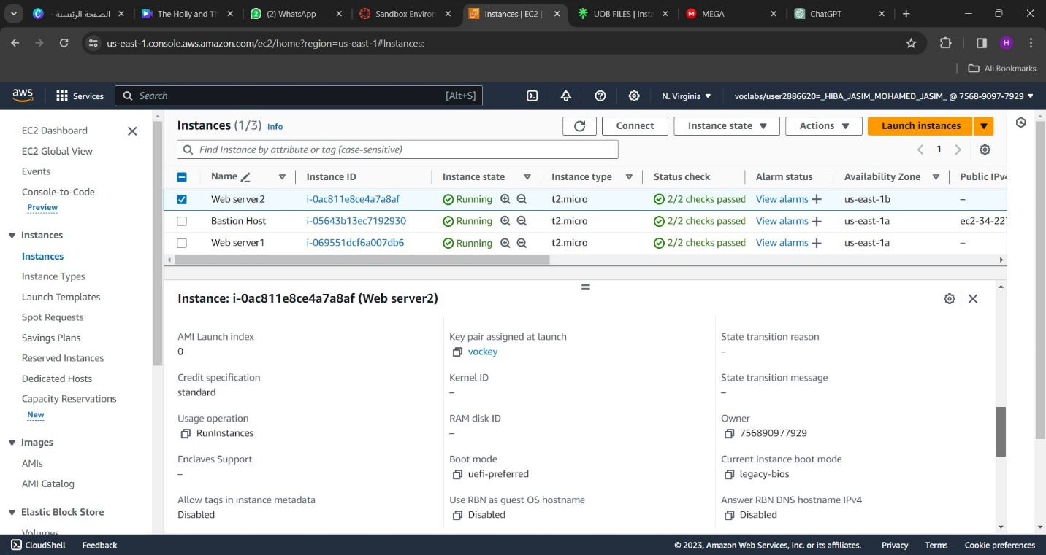

*Figure 13: web server2: details*

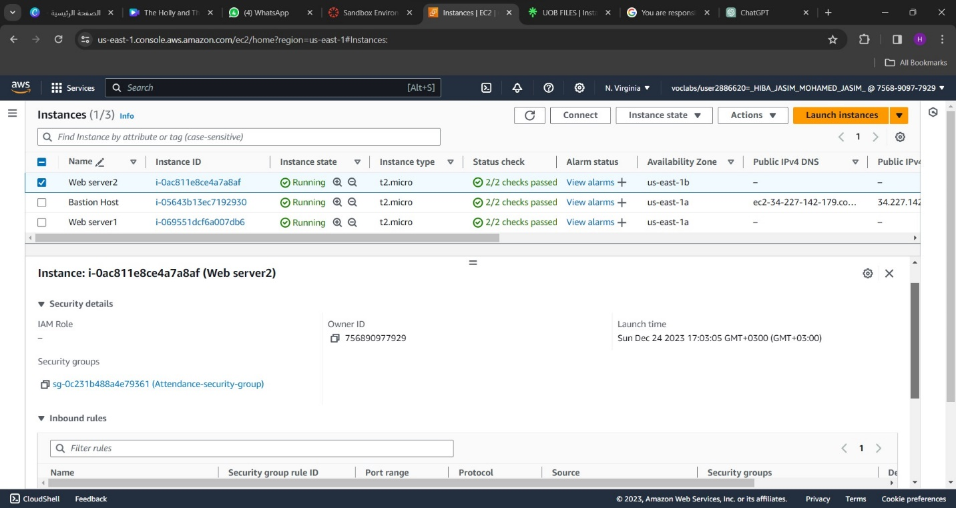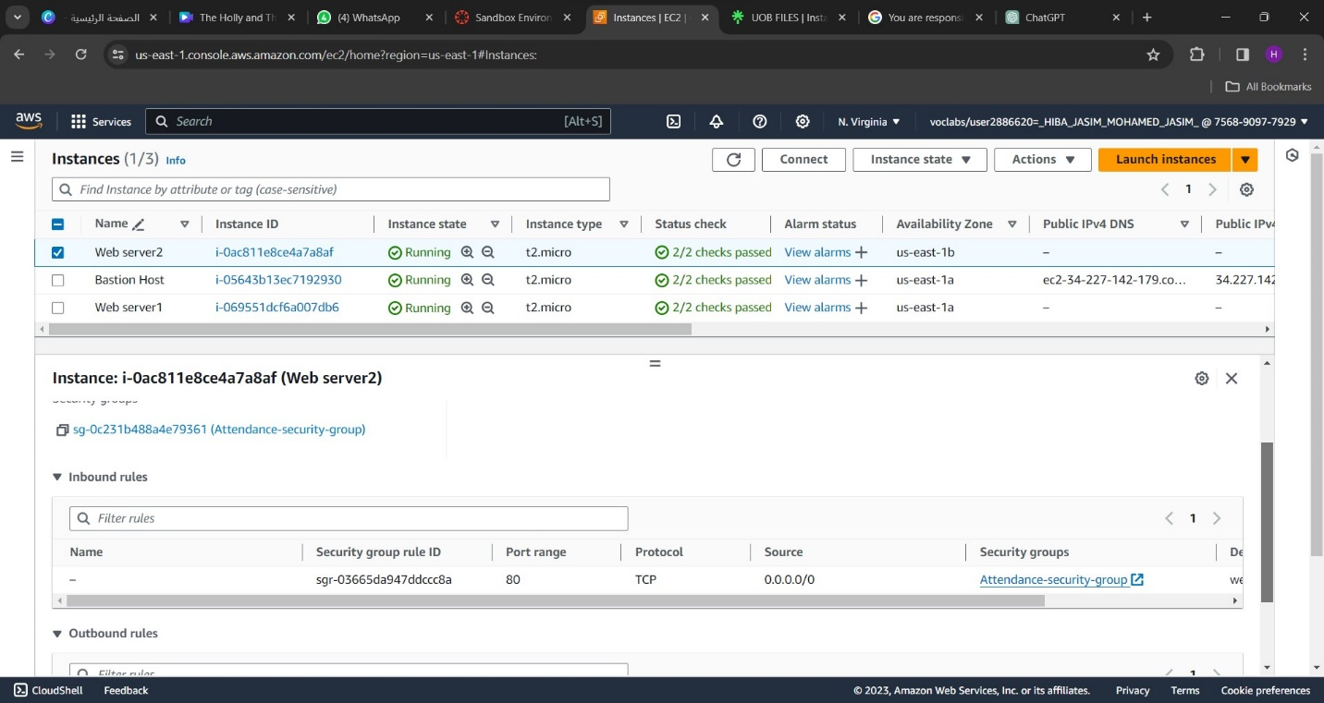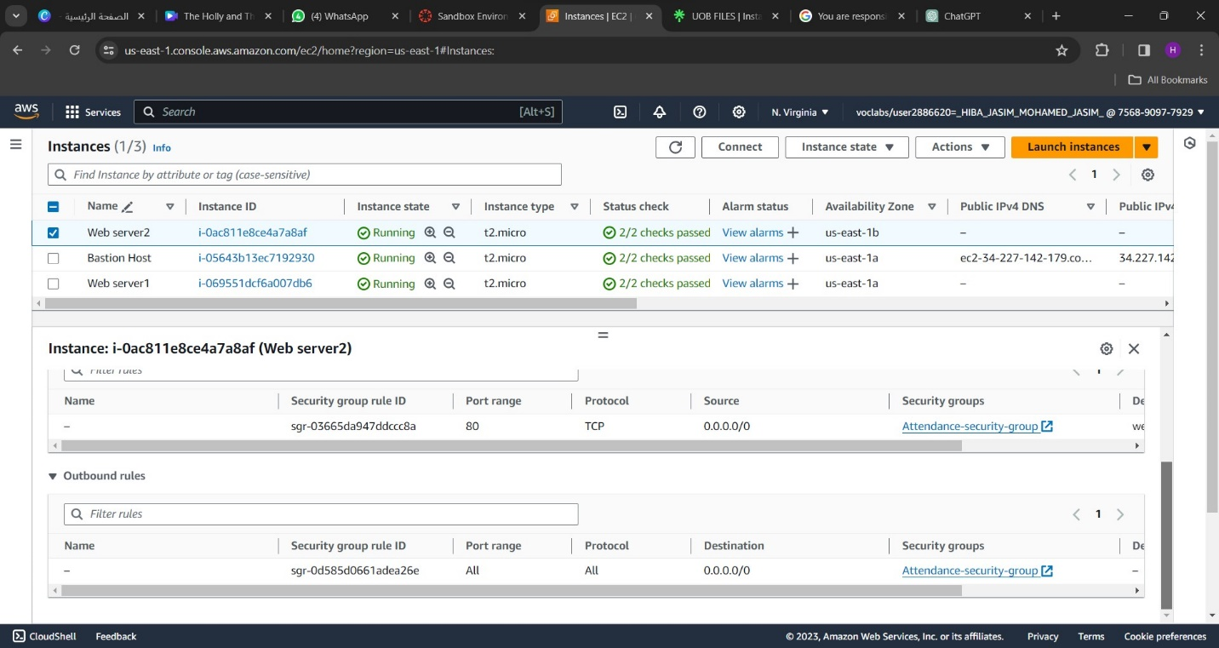

*Figure 14: web server2-security*

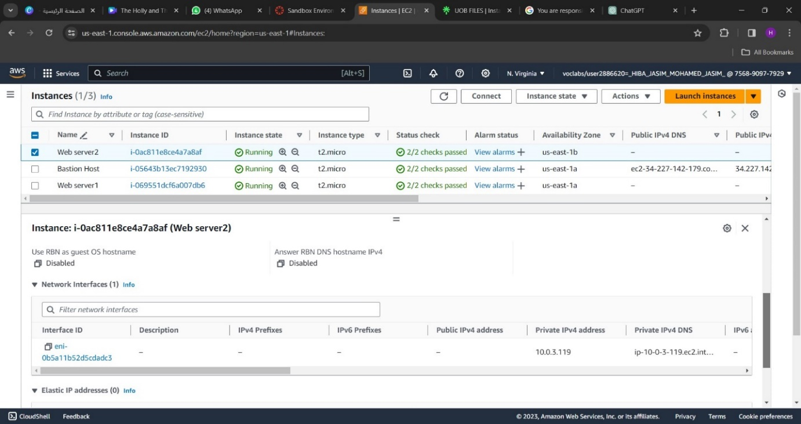

*Figure 15: Web server2-networking*

We added a load balancer that distributes incoming traffic between multiple servers, monitors server health, maintains session persistence, and manages SSL termination to improve attendance management system performance, scalability, and availability. It is essential to ensure a smooth user experience and maximize system performance.

* **Load balancer:**

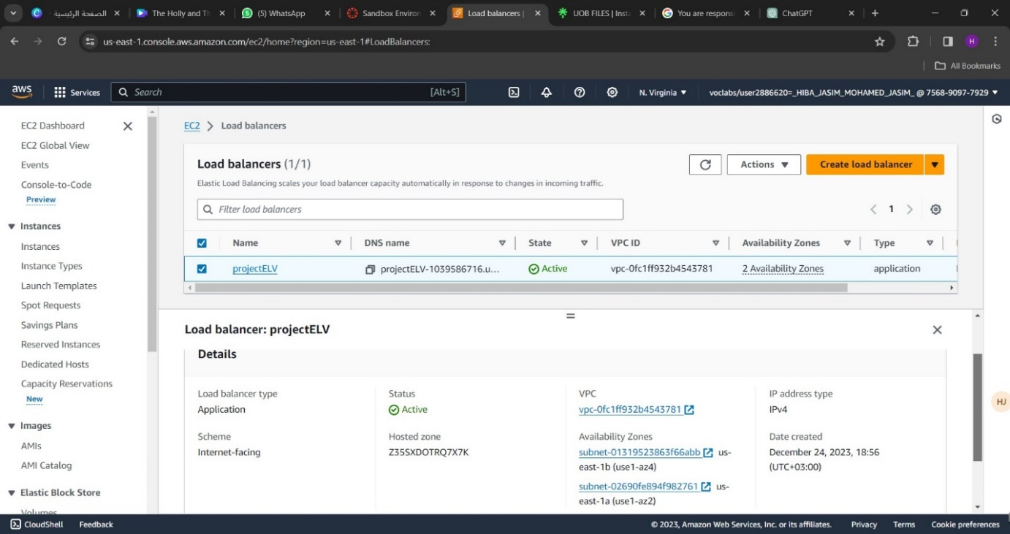

*Figure 16: Load balancer- projectELV*

## **The Challenges We Faced**

* In implementation, we did not have permission to create any type of database.

# **COST ESTIMATION**

By using AWS Pricing Calculator, we estimate the following:

*Figure 17: estimate summary.*

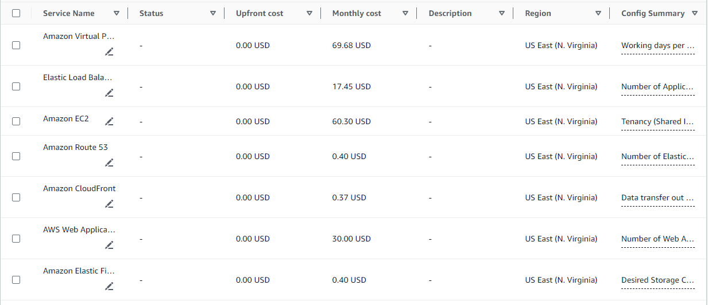

*Figures 18, 19: estimation details*

# **CONCLUSION**

In conclusion, we have designed a system that effectively captures attendance using cameras, processes images in the cloud for face recognition, and securely stores the data in a scalable database.

We prioritized security by implementing measures to protect sensitive information and ensure privacy. Additionally, we optimized the system's performance to improve image processing and face recognition efficiency.

Our project documentation provides a comprehensive overview of the system architecture, implementation details, and additional considerations. We also estimated the cost of implementing the system for an institution with 20,000 students and 1,000 sections per semester.

Overall, our solution meets the needs of SmartAttendance by offering a reliable, scalable, and secure attendance management system. It has the potential to streamline processes in educational institutions and enhance efficiency.